**House price prediction**

**1. Understand the Data:**

- Obtain a dataset with features such as the area, number of bedrooms, location, age of the property, and other relevant information.

- Understand the distribution of data, identify missing values, and handle outliers if necessary.

2. **Feature Selection Techniques:**

- **Univariate Selection:**

Select the features with the strongest relationship with the target variable. For instance, you can use statistical tests like ANOVA F-test or chi-squared test.

**- Feature Importance:**

Use techniques like decision trees or random forests to determine the importance of each feature in predicting the target variable.

- **Correlation Matrix with Heatmap:**

Analyze the correlation between features to identify redundant or highly correlated variables.

- **Recursive Feature Elimination:**

Use models that recursively remove the least significant features, based on the coefficients, until the specified number of features is reached.

**- L1 Regularization:**

Apply L1 regularization techniques like Lasso regression to automatically select the relevant features while penalizing the irrelevant ones.

3. **Data Preprocessing:**

- Handle missing values using techniques like mean or median imputation, or use advanced techniques like KNN imputation.

- Standardize or normalize the data to bring all the features to a common scale.

4. **Model Building:**

- Choose an appropriate regression algorithm like Linear Regression, Ridge Regression, Lasso Regression, Decision Trees, Random Forests, or Gradient Boosting Machines.

- Split the dataset into training and testing sets.

- Train the model on the training data and evaluate its performance on the testing data.

5. **Model Evaluation:**

- Use metrics like Mean Squared Error (MSE), Root Mean Squared Error (RMSE), and R-squared to evaluate the model's performance.

- Perform cross-validation to ensure the model's robustness.

6. **Iterate and Refine:**

- Based on the evaluation results, fine-tune the feature selection process or try different models to achieve the best possible prediction accuracy.

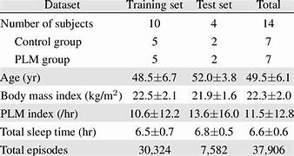

* **Coding for feature selection**

# Import necessary libraries

import pandas as pd

import numpy as np

from sklearn.model_selection import train_test_split

from sklearn.linear_model import LinearRegression

from sklearn.feature_selection import SelectKBest, f_regression

from sklearn.preprocessing import StandardScaler

from sklearn.metrics import mean_squared_error, r2_score

# Load the dataset

data = pd.read_csv('house_data.csv') # replace 'house_data.csv' with your dataset

# Perform data preprocessing

# Handle missing values

data = data.dropna()

# Define the features and target

X = data.drop('Price', axis=1)

y = data['Price']

# Feature selection using SelectKBest

selector = SelectKBest(score_func=f_regression, k=5) # select the top 5 features

X_new = selector.fit_transform(X, y)

# Split the data into training and testing sets

X_train, X_test, y_train, y_test = train_test_split(X_new, y, test_size=0.2, random_state=42)

# Standardize the data

scaler = StandardScaler()

X_train = scaler.fit_transform(X_train)

X_test = scaler.transform(X_test)

# Train the model

model = LinearRegression()

model.fit(X_train, y_train)

# Make predictions

y_pred = model.predict(X_test)

# Model evaluation

mse = mean_squared_error(y_test, y_pred)

r2 = r2_score(y_test, y_pred)

# Print the evaluation metrics

print('Mean Squared Error:', mse)

print('R-squared:', r2)

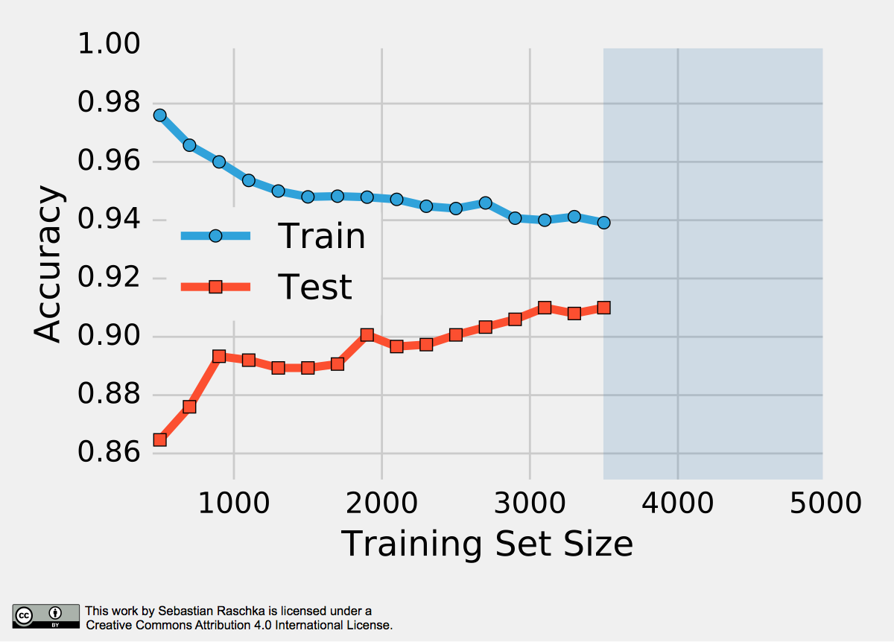

Coding for Model Training:

# Import necessary libraries

import pandas as pd

import numpy as np

from sklearn.model_selection import train_test_split

from sklearn.linear_model import LinearRegression

from sklearn.preprocessing import StandardScaler

from sklearn.metrics import mean_squared_error, r2_score

# Load the dataset

data = pd.read_csv('house_data.csv') # Replace 'house_data.csv' with your dataset

# Perform data preprocessing

# Handle missing values

data = data.dropna()

# Define the features and target

X = data.drop('Price', axis=1)

y = data['Price']

# Split the data into training and testing sets

X_train, X_test, y_train, y_test = train_test_split(X, y, test_size=0.2, random_state=42)

# Standardize the data

scaler = StandardScaler()

X_train = scaler.fit_transform(X_train)

X_test = scaler.transform(X_test)

# Train the model

model = LinearRegression()

model.fit(X_train, y_train)

# Make predictions

y_pred = model.predict(X_test)

# Model evaluation

mse = mean_squared_error(y_test, y_pred)

r2 = r2_score(y_test, y_pred)

# Print the evaluation metrics

print('Mean Squared Error:', mse)

print('R-squared:', r2)

